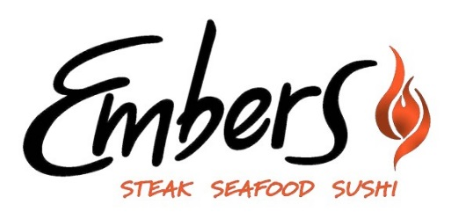
Happy Hour
4-6pm Daily

Happy Hour Menu
$4.50 Wine Glass
Line 39
California
Pinot Grigio
Chardonnay
Cabernet Sauvignon
Pinot Noir

$2.75 Bottle Beer
Miller Lite
Coors Light
Yuengling

$4.50 House Cocktails
Cosmopolitan
Harvest Margarita
Flirtini

$6 Small Bites
Mini Crabcakes
Spring Rolls
California Sushi Roll
Spicy Tuna Sushi Roll

Cheeseburger Slider
$3 Each

